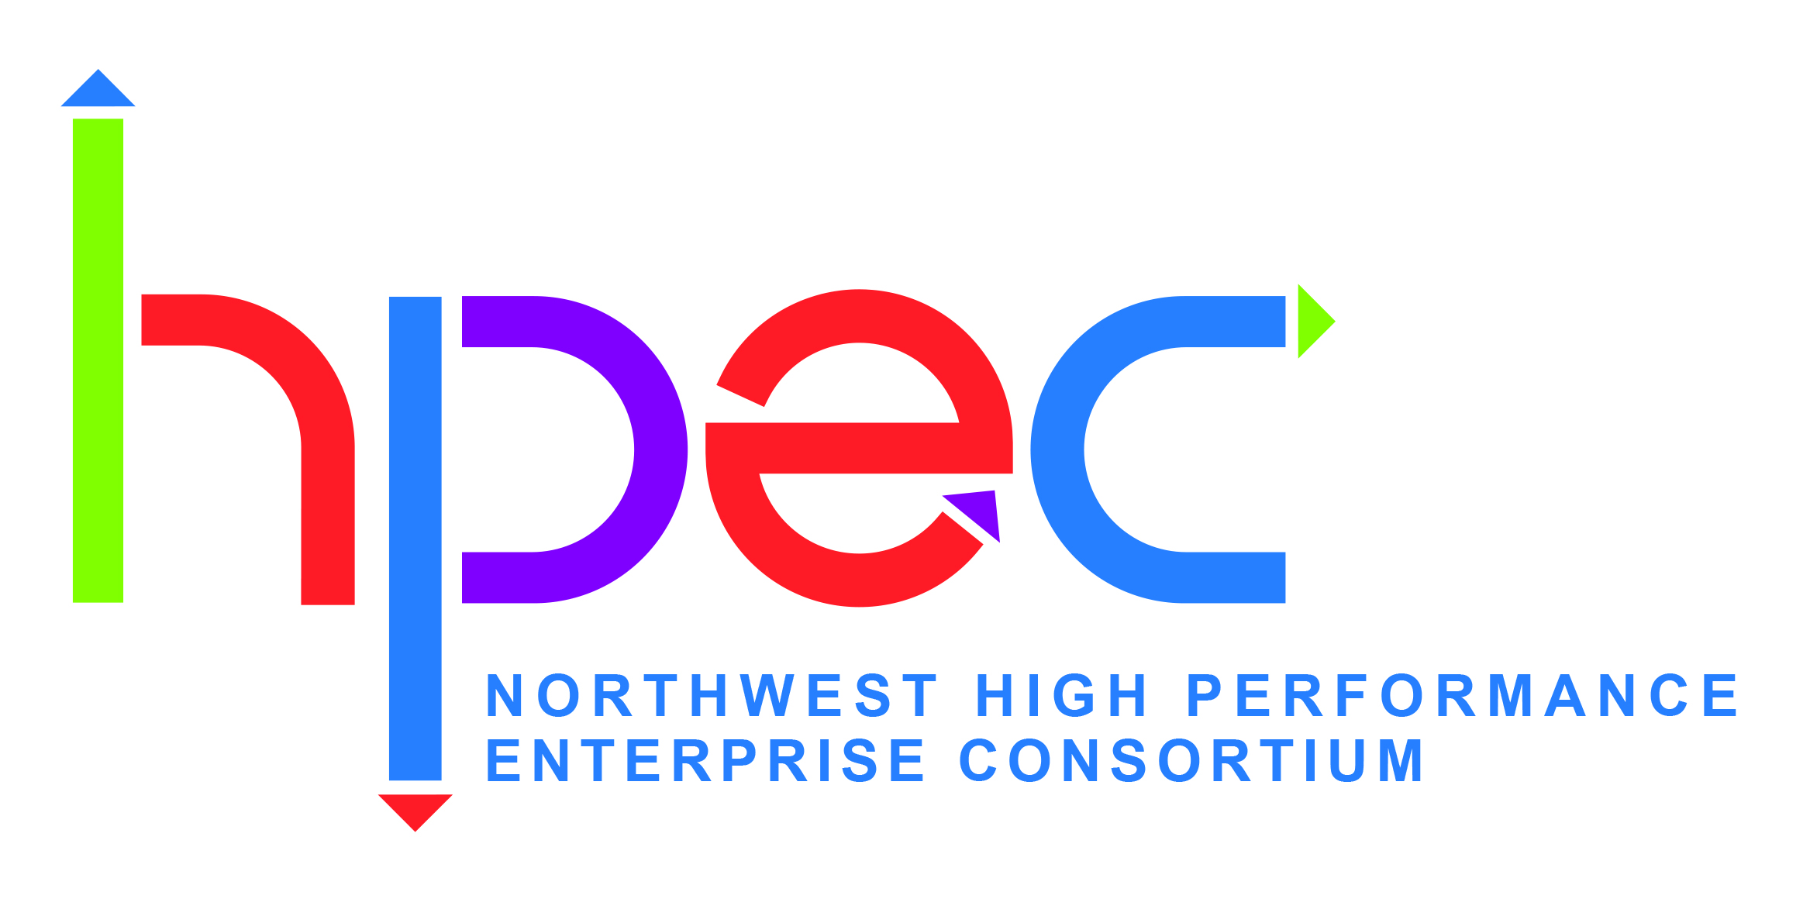

NWHPEC POLICY

Conditions for Membership Termination

Objective:

To define eligibility for membership and under what conditions membership would be terminated

Overview:

Membership may be granted to any enterprise that satisfies the criteria for admission as listed in the "Membership Guidelines". NWHPEC is a sharing organization and our strength is a "Give to Get" philosophy. Members are strongly advised to participate by attending and hosting NWHEPC sponsored activities. In order to better serve the members who are active in NWHPEC, termination of membership will take place under the conditions listed below.

Policy:

Membership will be terminated when one (or more) of the following occurs:

The member company fails to pay the membership fee within 6 months of invoice.

The member company dissolves.

The member company uses NWHPEC sponsored activities as a selling platform.

The member company requests to be removed as a member.

Related Policies/Procedures/Forms:

NWHPEC Membership Guidelines

